**ASSIGNMENT-11.1:**

Write the Pig codes to analyze the petroleum data set.

1. What is the total amount of petrol in volume sold by every distributor?

**Pig Script:**

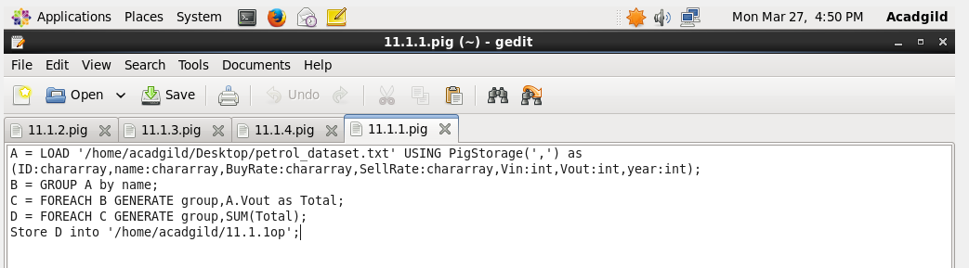

**Execution of the Pig Script:**

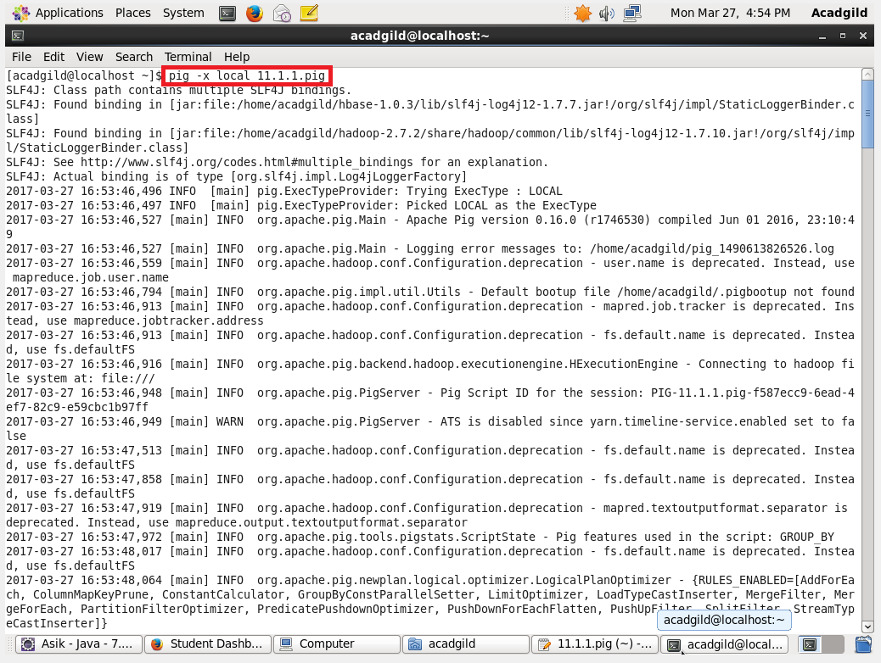

**Output:**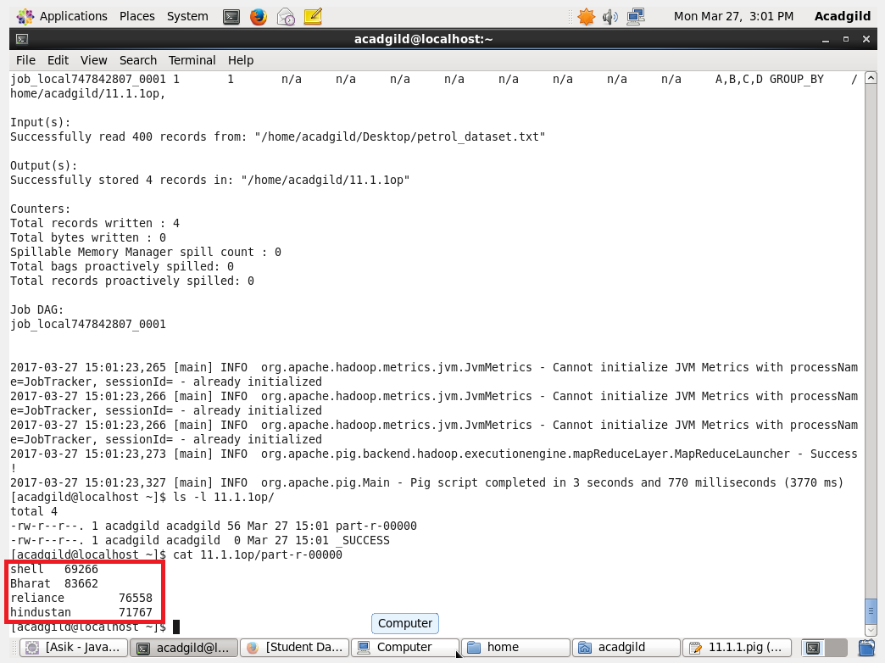

2.) Which are the top 10 distributors ID's for selling petrol? Also display the amount of petrol sold in volume.

**Pig Script:**

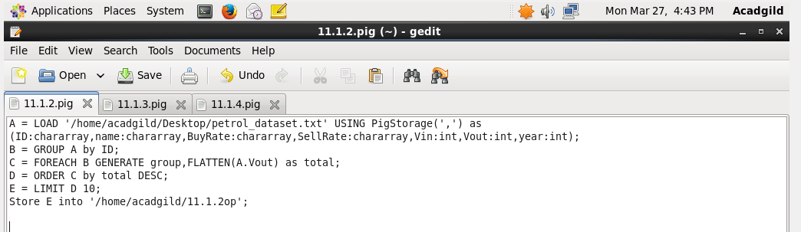

Executing the Pig Script: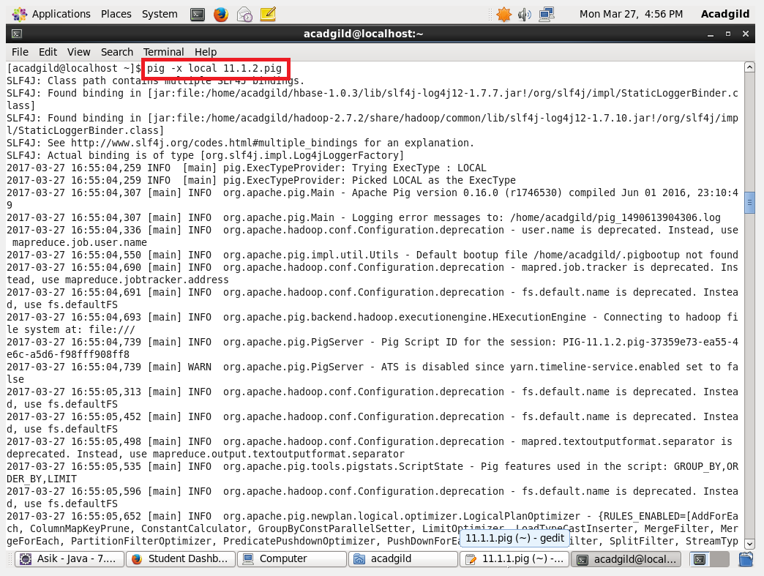

**Output:**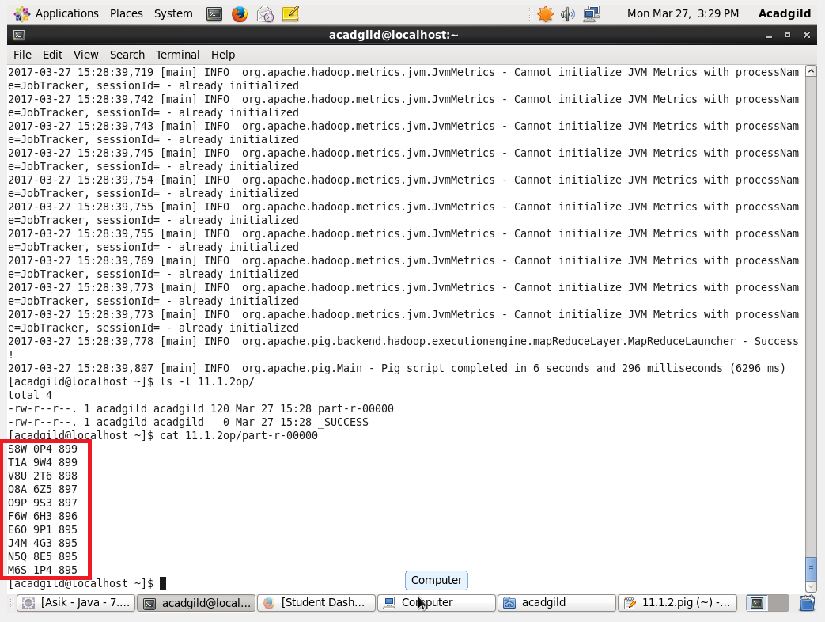

3.) List 10 years where consumption of petrol is more with the distributer id who sold it

**Pig Script:**

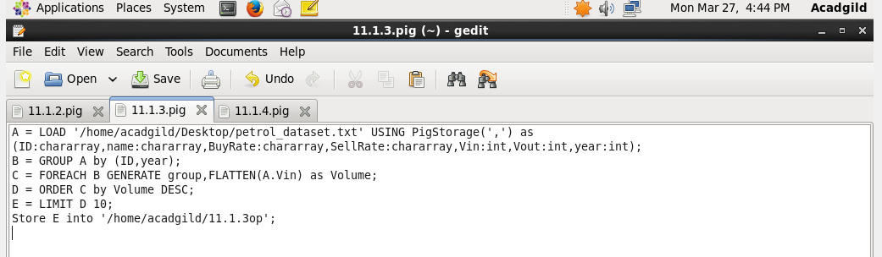

**Executing the Pig Script:**

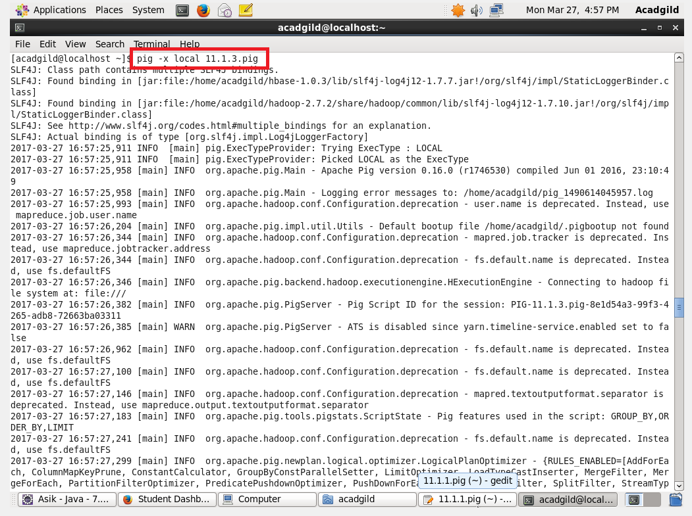

**Output:**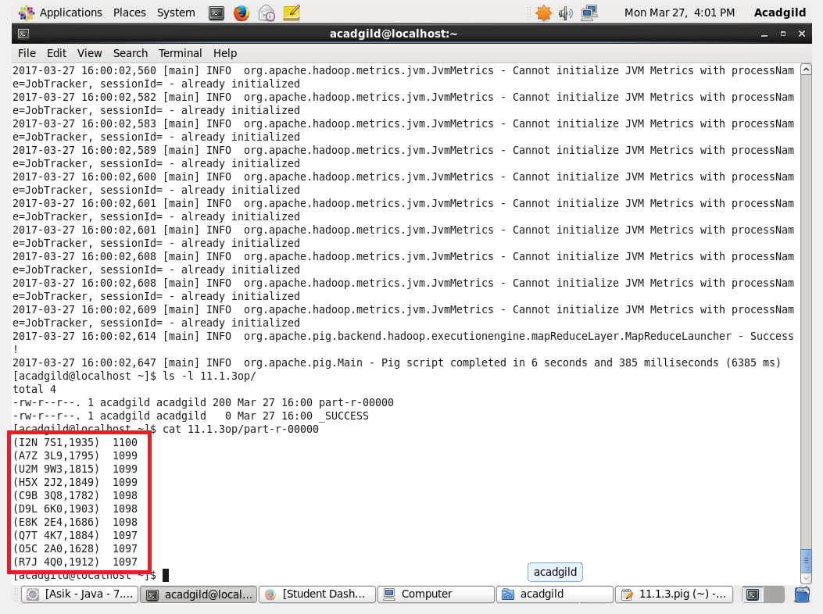

4. )Find the distributer name who sold petrol in least amount.

**Pig Script:**

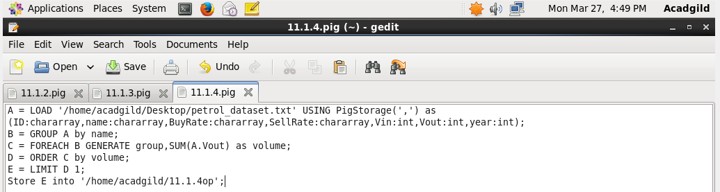

**Executing the Pig Script:**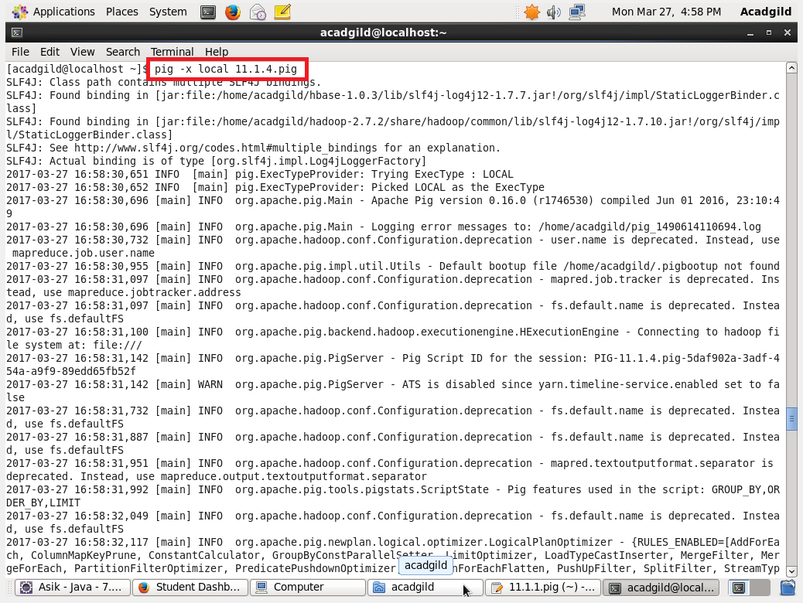

**Output:**